Internship Application | 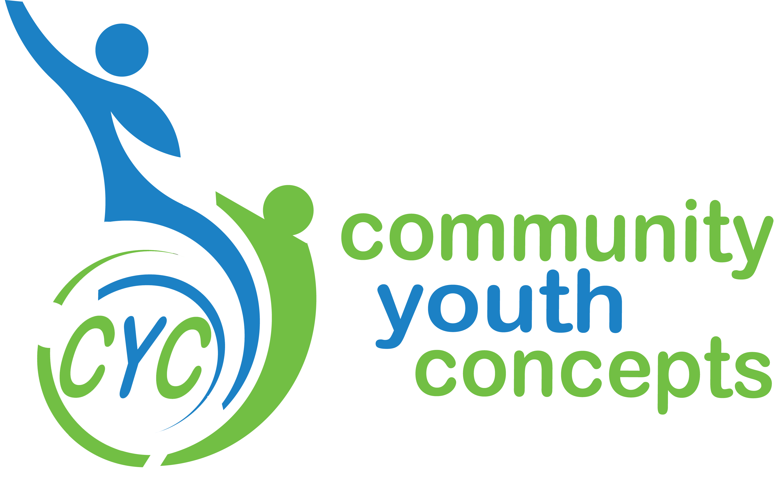

Contact Information
Name
Street Address
City ST ZIP Code
Phone
E-Mail Address

Availability

Please list times you would be available for each day:
Monday | Thursday
Tuesday | Friday
Wednesday | Saturday

School Information

School Attending:
Would this internship be used as part of a graduation or class requirement?

How many hours are required?

Between what dates does the internship need to be completed.

Name and email of faculty member overseeing this experience:

Please list any additional requirements, or send along with application.

Internship Interests

What are you hoping to gain from an internship with Community Youth Concepts

What compelled you to inquire about an internship with Community Youth Concepts?

Special Skills or Qualifications

Summarize special skills and qualifications you have acquired from employment, previous volunteer work, or through other activities.

Previous Experience

Summarize your previous volunteer and work experience, as it would relate to this internship.

Agreement and Signature

By submitting this application, I affirm that the facts set forth in it are true and complete. I understand that if I am accepted as an intern, any false statements, omissions, or other misrepresentations made by me on this application may result in my immediate dismissal. I also understand that acceptance is conditional on the results of a Criminal Background Check and check of the National Sex Offender Public Registry.
Name (printed)
Signature
Date

Our Policy

It is the policy of this organization to provide equal opportunities without regard to race, color, religion, national origin, gender, sexual preference, age, or disability.

Thank you for completing this application form and for your interest in interning with us. Please send along with resume and any other internship requirements to mollie@cyconcepts.org

